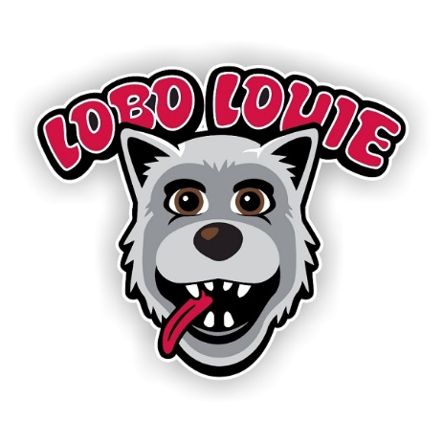
Program Name: Lobo Louie Colombia Program
Dates of Travel: July 1- 15, 2022
Sponsoring Department & Org: Example Department; 064A
Department Contact Name: Lobo Lucy
E-mail: LoboLucy@unm.edu
Phone: 277-0001
Department Index and Account Code: 064xxx-08Z0
Deposit Amount: $500.00
Deposit Type (Circle one): Cash Check Credit Card
Student Name: _____________
Student Banner ID:

*Complete this form and take it with you to the Cashier’s Office (in the UNM Business Center on Lomas and University) with your payment. Once you receive a receipt of payment, please send it to the Department Contact specified above. Thank you!

